










FROM THE DESK OF PRESIDENT

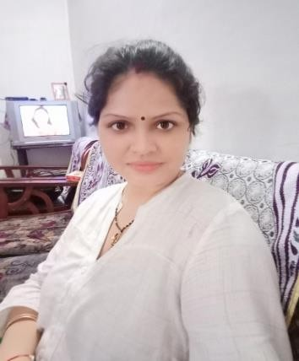
Dear Friends, The year under review has been a landmark year for Kalam Sewa Samiti. The organization carried out a visioning exercise on environment, education, unemployment and waste resource management and others. This address the reality that the thousands of unemployed people, and many students are garbage pikers in Delhi, Agra, Uttar Pradesh and other regions. The result areas have been identified. The numbers to be impacted have been arrived at. Over the next two year, Kalam Sewa Samiti will focus on achieving the maximum impact in selected areas of social welfare.

(Shweta Nagar) Chairperson
Kalam Sewa Samiti

INTRODUCTION OF THE ORGANIZATION
Introduction:- Some eminent persons in the year 2019 decided to form a welfare development organization. The organization named was “Kalam Sewa Samiti” Regd. Address:- WZ-553,Nangal Raya Extension-2,New Delhi. Registered Social organization was established with a mission for the welfare of the Scheduled Castes. Tribes, Backward Classes, Minorities Disabled Persons, Older Persons weaker section and other development of the society through its various approach. “Kalam Sewa Samiti”, is interested in those welfare projects, which empower local Communities by giving them economic strength. It primarily focuses on the welfare of women and children of disadvantage section of the society.

The organization has good infrastructure and well-qualified trained staff for the implementation of Programmed/activities retaliated with the aims and objective of the society as per registered bye laws.

- To make the best efforts for environment awareness, women empowerment, welfare of ST/SC, provide quality education to garbage pickers and handicapped students, and women empowerment.
- To help women by providing seminars and training programmed for their safety and all over development.
- To help the street children by providing them shelter, food and education.
- To organize seminar on social justice, legal rights of women granted through various legislation, conducting vocational training to empower women folk living below poverty line to import elementary education to those children who are deprived of literacy rights.
- To create a sense of brother hood, corporation, mutual harmony, love and affection amongst the members of the society and also amongst the general public.

Consumers Awareness Programm
The "Consumers Awareness Programme" organized by Kalam Sewa Samiti is likely an initiative aimed at educating consumers about their rights, responsibilities, and best practices related to consumption. Such programs are commonly organized by consumer advocacy groups, NGOs, or government bodies to empower individuals with information regarding product quality, safety standards, fair pricing, and avenues for redressal in case of grievances.
Here's a general outline of what such a program might include:
- Introduction to Consumer Right : Providing information on how to identify safe and quality products, understanding product labels, and recognizing counterfeit or substandard goods.

- Consumer Responsibility: Emphasizing the importance of responsible consumption, such as reading product labels, using products as intended, and reporting any issues promptly.
- Legal Framework : Providing an overview of consumer protection laws and regulations, including avenues for seeking redressal in case of disputes or fraud.
- Price Awareness : Helping consumers understand fair pricing practices, how to compare prices, and avoid exploitation by sellers.
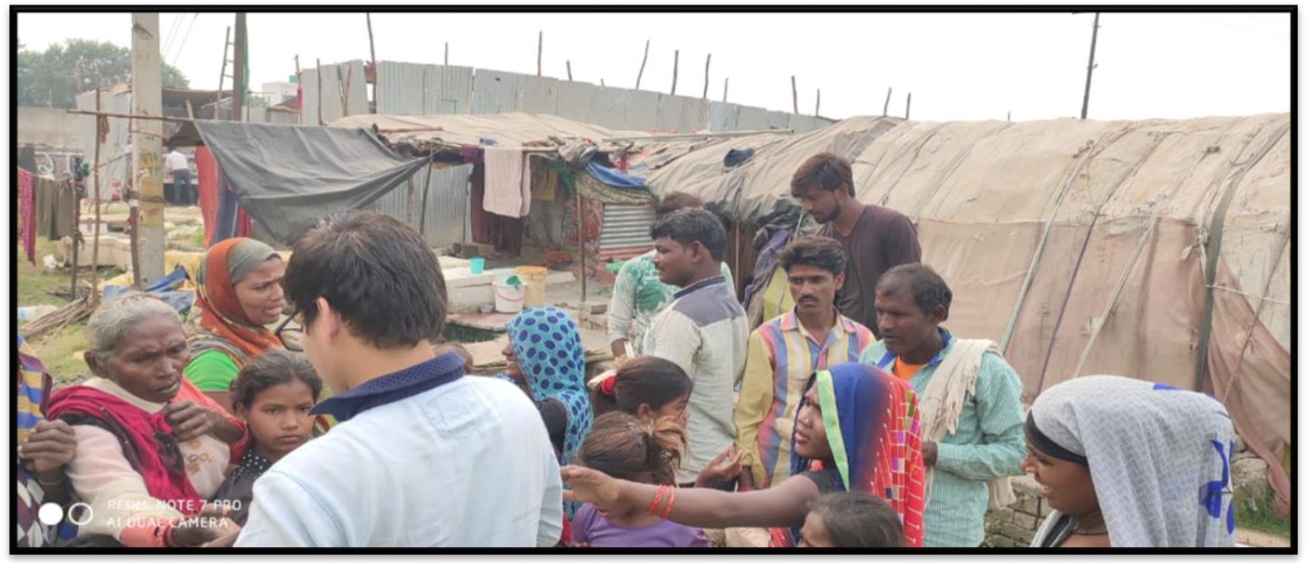

Help to old & poor People
Helping the elderly and impoverished is a noble initiative, and if Kalam Sewa Samiti is organizing such programs, it likely involves a range of activities aimed at providing assistance and support to these vulnerable groups. Here are some ways in which they might be helping:
- Distribution of Essential Supplies: Providing food, clothing, blankets, and other essential items to elderly individuals and impoverished families who may struggle to afford them.
- Medical Assistance: Offering medical check-ups, consultations, and access to affordable healthcare services for elderly individuals who may have limited mobility or financial resources.
- Financial Support: Providing financial assistance to elderly individuals and impoverished families to help cover expenses such as medical bills, utility bills, rent, or other necessities.

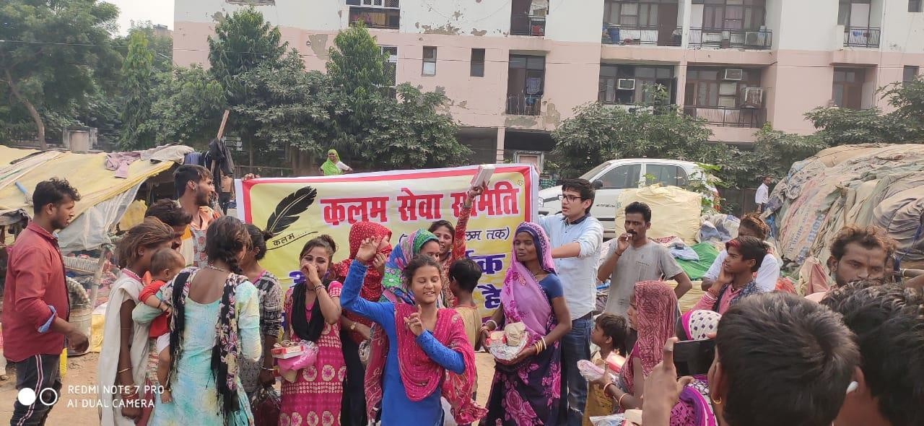

Meeting mahila panchayat & yoga
Organizing meetings of Mahila Panchayats (women's councils) and yoga sessions reflects Kalam Sewa Samiti's dedication to women's empowerment and holistic well-being. Here's how these initiatives unfold:
- Mahila Panchayat Meetings:
  - Empowerment Workshops: Conducting workshops focused on women's rights, leadership skills, financial literacy, and entrepreneurship to empower women within the community.
  - Legal Awareness: Providing information about legal rights and resources available to women, including avenues for seeking justice in cases of domestic violence, harassment, or discrimination.
  - Health and Hygiene: Educating women about reproductive health, hygiene practices, nutrition, and access to healthcare services for themselves and their families.
  - Skill Development: Offering training programs and vocational courses to enhance women's skills and employability, enabling them to become more financially independent.
- Yoga Sessions:
  - Physical Health: Conducting yoga sessions to promote physical health, flexibility, and overall well-being among participants, including women of all ages.
  - Mental Wellness: Teaching relaxation techniques, mindfulness practices, and breathing exercises to reduce stress, anxiety, and improve mental health.
  - Community Building: Providing a space for individuals to come together, socialize, and support each other in their wellness journeys.
  - Inclusivity: Ensuring that yoga sessions are accessible to individuals of all fitness levels and abilities, including modifications and adaptations as needed.

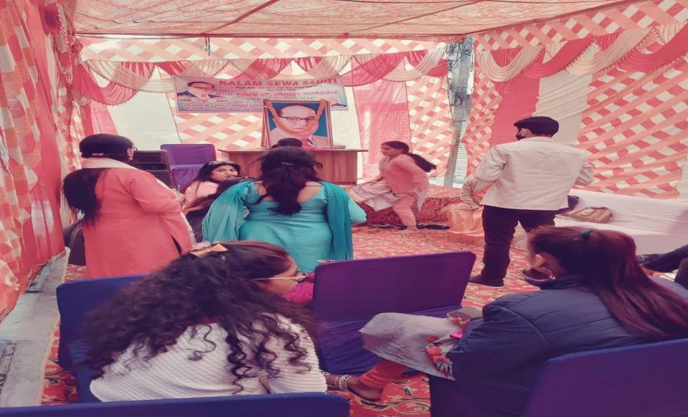

Enviroment Awareness programme
The "Environment Awareness Programme" organized by Kalam Sewa Samiti reflects a commitment to raising awareness about environmental issues and promoting sustainable practices within communities.
Here's how such a program structured:
- Education and Information: The program would include educational sessions and workshops to inform participants about various environmental issues such as climate change, pollution, deforestation, waste management, and biodiversity loss. These sessions may incorporate multimedia presentations, guest speakers, and interactive activities to engage participants.

- Community Engagement: Kalam Sewa Samiti would engage community members, including individuals, families, schools, and local businesses, in discussions and activities aimed at fostering a sense of environmental stewardship. This may include organizing community clean-up events, tree planting drives, and eco-friendly initiatives.
- Awareness Campaigns: The organization may launch awareness campaigns using various communication channels such as posters, flyers, social media, and local media outlets to reach a wider audience. These campaigns would aim to highlight the importance of environmental conservation and encourage behavior change towards more sustainable practices.

By organizing Environment Awareness Programmes, Kalam Sewa Samiti aims to empower individuals and communities to become agents of positive change for the environment, promoting conservation, sustainability, and a greener future for all.

Health Camp & Awareness Programm
Organizing health camps and awareness programs is a commendable initiative by Kalam Sewa Samiti, aimed at promoting community health and well-being. Here's how such events structured:

- Health Camps:
  - Medical Check-ups: Providing free or subsidized medical check-ups by qualified healthcare professionals, including general physicians, specialists (e.g., dermatologists, ophthalmologists), and dentists.
  - Diagnostic Tests: Offering diagnostic tests such as blood pressure monitoring, blood sugar tests, cholesterol checks, and basic screenings for common ailments.
  - Immunizations: Providing vaccinations and immunizations for preventable diseases, particularly targeting children, pregnant women, and vulnerable populations.
  - Health Education: Conducting educational sessions on topics such as nutrition, hygiene, family planning, maternal and child health, and the importance of regular exercise.
- Awareness Programs:
  - Disease Prevention: Raising awareness about common diseases, their symptoms, risk factors, and preventive measures through interactive workshops, seminars, and information sessions.
  - Healthcare Rights and Services: Educating community members about their rights as patients, available healthcare services, and how to navigate the healthcare system effectively.
  - Nutrition and Healthy Living: Providing information on healthy eating habits, balanced diets, food safety, and the importance of physical activity for maintaining overall health and wellness.
  - Personal Hygiene: Promoting good hygiene practices, including handwashing, sanitation, and safe water management, to prevent the spread of infectious diseases.

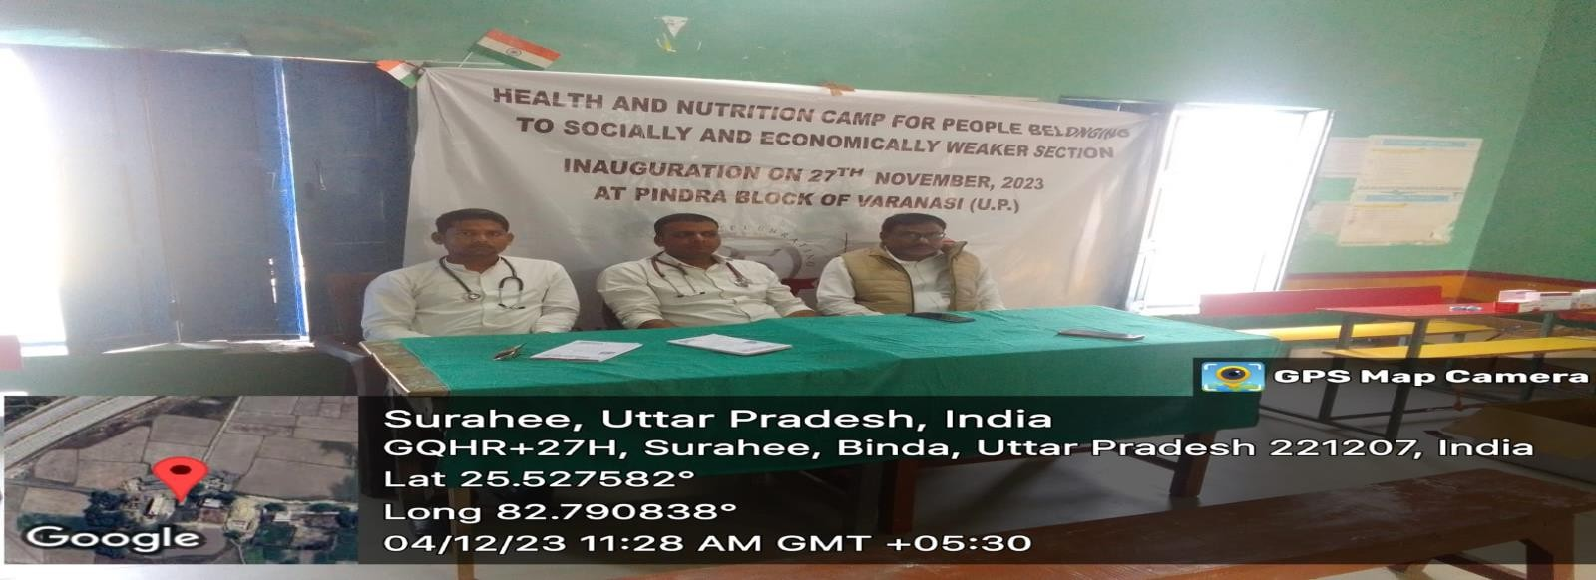

Cultural Programm
A cultural program organized by Kalam Sewa Samiti could encompass a variety of events and activities aimed at celebrating and promoting cultural diversity, fostering community engagement, and preserving traditional arts and heritage. Here are some components that might be included in such a program:
- Cultural Performances: Showcase of traditional music, dance, theater, and other performing arts forms representing various regions and communities. This could include folk dances, classical music recitals, theatrical performances, and storytelling sessions.

- Art and Craft Exhibitions: Display of local handicrafts, artworks, and traditional crafts showcasing the skills and creativity of artisans within the community. Visitors may have the opportunity to purchase or learn about the cultural significance of these crafts.

- Cultural Workshops and Demonstrations: Hands-on workshops and demonstrations where participants can learn traditional art forms, culinary techniques, or crafts such as pottery, weaving, or painting. This provides an opportunity for intergenerational learning and skill-sharing.

- Cultural Competitions: Organizing competitions such as singing contests, dance-offs, or art competitions to encourage participation and talent development among community members, especially youth.
- Celebration of Festivals: Organizing events to celebrate religious or cultural festivals observed by the community, such as Diwali, Eid, Christmas, or local harvest festivals. These celebrations can include rituals, music, dance, and traditional customs.

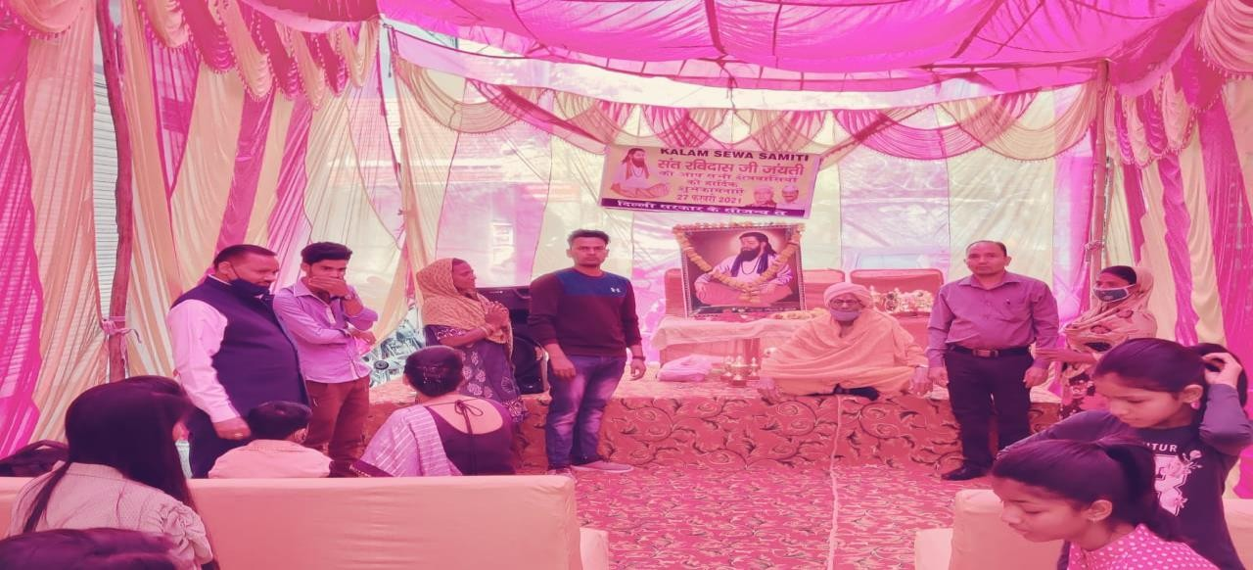

Vocational Training SC/ST/OBCMinority
Organizing vocational training programs for marginalized communities such as SC (Scheduled Castes), ST (Scheduled Tribes), OBC (Other Backward Classes), and minorities demonstrates Kalam Sewa Samiti's commitment to promoting social inclusion, economic empowerment, and skill development among these groups. Here's how such programs structured:

Identifying Training Needs:
  - Conducting surveys and assessments to identify the specific vocational skills needed within the SC/ST/OBC minority communities.
  - Consulting with community leaders, local authorities, and experts to determine the most relevant and beneficial training programs.

Designing Tailored Training Programs:
  - Developing vocational training courses based on the identified needs and interests of the target communities.
  - Offering a variety of skill development opportunities, including courses in sectors such as agriculture, handicrafts, healthcare, hospitality, construction, IT, and entrepreneurship.
By organizing vocational training programs for SC/ST/OBC minority communities, Kalam Sewa Samiti contributes to breaking the cycle of poverty, enhancing employability, and promoting socio-economic empowerment among marginalized groups.

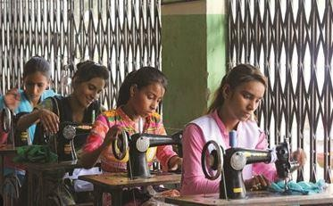

Development Programm SC/STMinority Skill
The Skill Development Program for SC/ST and minority communities organized by Kalam Sewa Samiti is likely designed to address the specific needs and challenges faced by these marginalized groups.
Here's an overview of what such a program might entail:
- Identifying Skill Gaps: Conducting assessments to identify the specific skills needed by members of the SC/ST and minority communities to enhance their employability and economic opportunities.

- Tailored Training Programs: Designing training programs tailored to the needs and interests of participants, which may include vocational skills, technical skills, soft skills (such as communication and teamwork), entrepreneurship, and financial literacy.

- Access to Education and Training: Facilitating access to formal education and vocational training opportunities for individuals who may have faced barriers to education and skill development in the past.
- Advocacy and Policy Engagement: Advocating for policies and initiatives that promote equal access to education, training, and employment opportunities for SC/ST and minority communities at the local, regional, and national levels.
Through these initiatives, Kalam Sewa Samiti aims to empower individuals from marginalized communities, break the cycle of poverty and discrimination, and promote inclusive economic growth and social development.

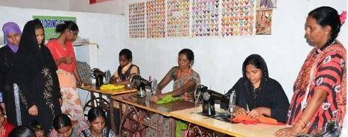

Educational Awareness Programm
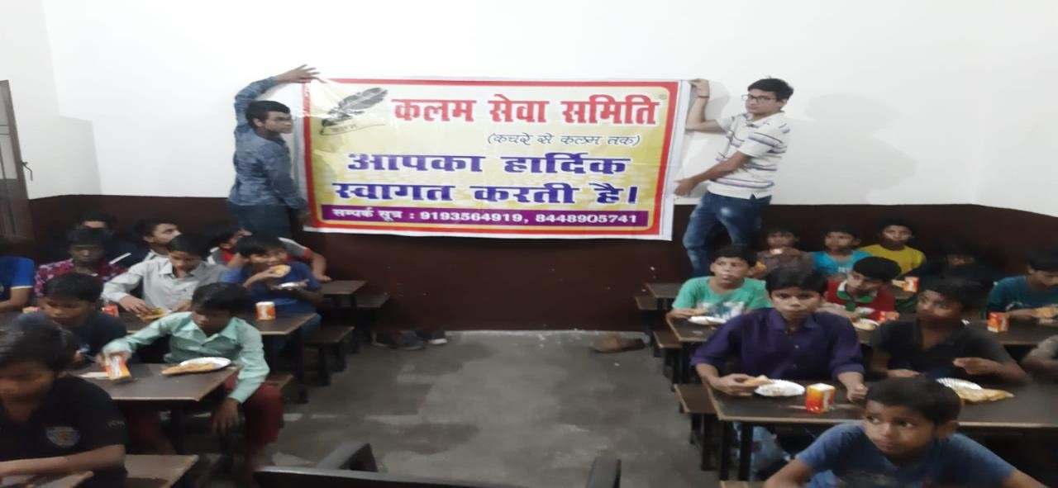

The "Educational Awareness Programme" organized by Kalam Sewa Samiti likely aims to promote awareness about the importance of education and provide support to enhance educational opportunities for individuals in the community. Here's how such a program might be structured:

Awareness Workshops:
  - Importance of Education: Educating community members about the value and benefits of education in improving livelihoods, breaking the cycle of poverty, and fostering personal growth and development.
  - Access to Education: Highlighting the significance of access to quality education for all, regardless of socio-economic background, gender, or other factors.
  - Educational Rights: Informing individuals about their rights to education as enshrined in national and international laws and advocating for the fulfillment of these rights.

  - Through the Educational Awareness Programme, Kalam Sewa Samiti endeavors to empower individuals with the knowledge, resources, and opportunities needed to pursue education, fulfill their potential, and contribute to the socio-economic development of the community.

Computer Training SC/ST/OBCMinority
Organizing computer training programs specifically targeted towards marginalized groups such as SC (Scheduled Castes), ST (Scheduled Tribes), OBC (Other Backward Classes), and minorities is a commendable initiative by Kalam Sewa Samiti. Here's how such programs might be structured and what they could entail:

Basic Computer Skills Training:
  - Providing fundamental training in computer literacy, including understanding hardware and software, using operating systems (e.g., Windows), and navigating common software applications (e.g., Microsoft Office Suite). Teaching essential skills such as typing, file management, internet browsing, and email communication.
  - Specialized Training Modules:Offering training in specialized software relevant to various industries or job sectors to enhance participants' employability and career prospects.
  - Internet and Digital Literacy:Educating participants about internet safety, online privacy, and responsible use of digital resources.
Providing guidance on accessing online information, conducting research, and utilizingonline services for personal and professional purposes.By organizing computer training programs for marginalized groups, Kalam Sewa Samiti helps bridge the digital divide, empower individuals with valuable skills, and promote social and economic inclusion within the community.Top of Form

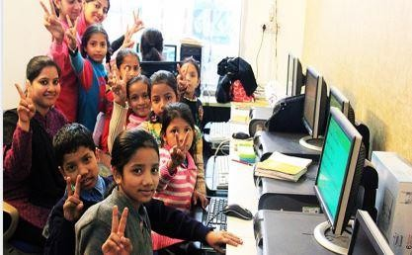

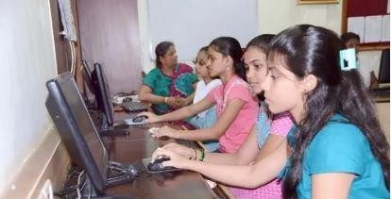

Wowen Awareness Programm
The "Women Awareness Program" organized by Kalam Sewa Samiti is likely designed to educate and empower women on various issues relevant to their well-being, rights, and roles within society. Here's how such a program might be structured:

Gender Equality and Women's Rights:
  - Educating women about their fundamental rights, including rights to education, healthcare, employment, property ownership, and freedom from discrimination and violence.
  - Raising awareness about gender equality and the importance of women's participation in decision-making processes at all levels of society.

Health and Hygiene
  - Providing information on reproductive health, maternal and child healthcare, family planning, and hygiene practices to promote the well-being of women and their families.
  - Offering workshops or sessions on nutrition, exercise, and mental health awareness to support overall wellness.

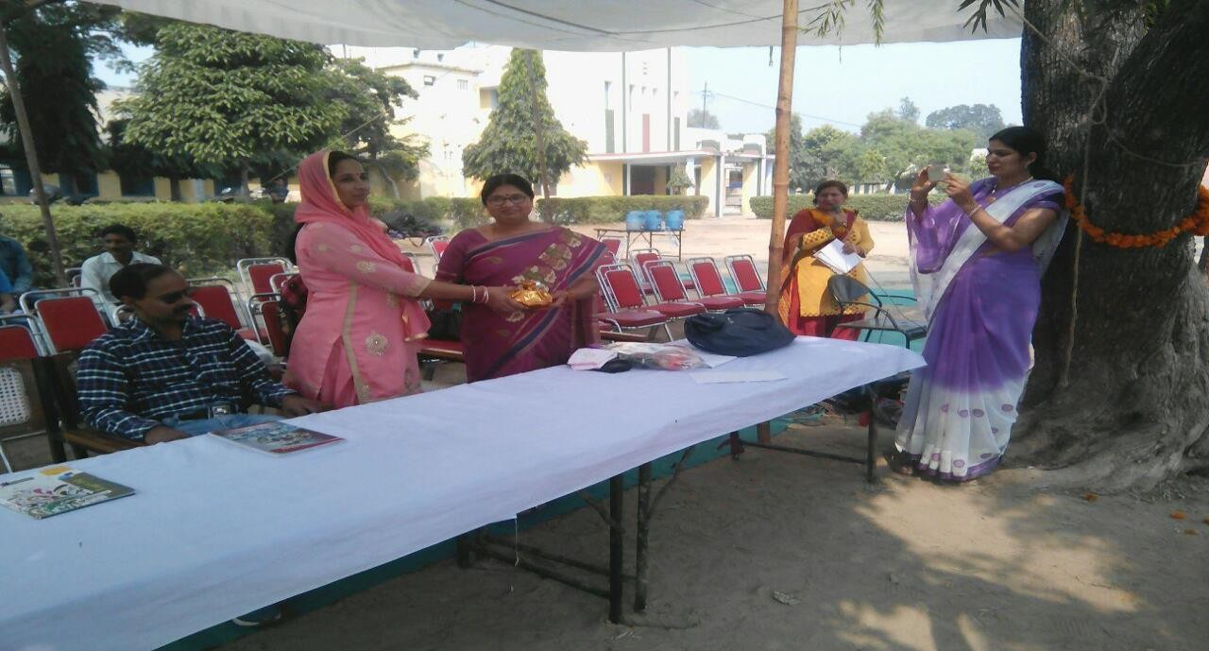

Distribution of medical kit
The distribution of medical kits organized by Kalam Sewa Samiti is a commendable initiative aimed at providing essential healthcare resources to those in need. Here's how such an initiative might typically unfold:
- Assembly of Medical Kits: Once the supplies are obtained, volunteers or staff members would assemble the medical kits. Each kit would be carefully curated to meet the specific healthcare needs of the recipients, taking into account factors such as age, medical conditions, and common ailments in the community.

- Distribution Events: Distribution events may be organized at central locations within the community, where individuals can come to receive their medical kits. Volunteers would be on hand to assist with the distribution process, provide information on the use of the medical supplies, and address any questions or concerns.

By organizing the distribution of medical kits, Kalam Sewa Samiti plays a crucial role in improving access to healthcare resources, promoting health awareness, and empowering individuals to lead healthier lives.
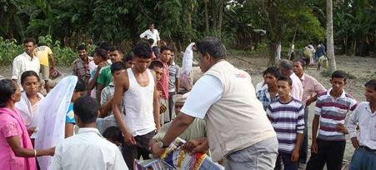

Distribution of Health kit & Nutrition Food
The distribution of health kits and nutrition food organized by Kalam Sewa Samiti demonstrates a commitment to addressing both the immediate health needs and the long-term nutritional requirements of communities. Here's how such an initiative might be implemented:

- Nutrition Food Packages: Kalam Sewa Samiti would also source or create nutrition food packages designed to address specific nutritional deficiencies or dietary needs within the community. These packages may include staples like rice, lentils, pulses, fortified cereals, cooking oil, fruits, vegetables, and protein-rich foods like nuts or canned fish.
- Health Kit Contents: The organization would procure or assemble health kits containing essential items for basic healthcare. These may include items such as first aid supplies (bandages, antiseptics, pain relievers), hygiene products (soap, hand sanitizer), oral rehydration salts (ORS), basic medications (for common ailments like fever, cough, diarrhea), and health education materials.
- Nutrition Education: Alongside the distribution of nutrition food packages, Kalam Sewa Samiti may offer nutrition education sessions to raise awareness about the importance of balanced diets, healthy eating habits, and the role of nutrition in overall health and well-being. These sessions may include cooking demonstrations, recipe sharing, and discussions on dietary diversity.
By organizing the distribution of health kits and nutrition food packages, Kalam Sewa Samiti aims to improve access to essential healthcare resources, address nutritional deficiencies, and promote better health outcomes for individuals and families in need.

